The Storytelling Company FZE
Fujaiarah Creative Tower
P.O Box 4422 Fujairah
United Arab Emirates
Dubai

17th November 2018

To whom it may concern:

This is Paola Balbi, the Artistic Director of “Tales on the Island - International Storytelling Festival in Sharjah,” organized by The Storytelling Company on behalf of Shurooq-Sharjah Investiment and Development Authority in the United Arab Emirates. (The Chairperson of this Government body of the Emirate of Sharjah is HRH Sheikha Budour bint Sultan bin Mohammed Al Qasimi.) The Festival has come to its third edition and has been the first and now most established Storytelling Festival of the Gulf Countries (GCC) and the Middle East.

I'm writing as we wish to invite US Storyteller Katie Knutson as one of our featured artists for 2019. Sharjah has been appointed by UNESCO World Book Capital for 2019, therefore this year we will have a special edition of the Festival with great involvement of schools across the seven Emirates. We think that Katie, with her extensive experience as a teachers' trainer and Storytelling facilitator in schools, as well as a performing Storyteller, would be a great contribution to our lineup. I have had the opportunity to see Katie work both in Canada in 2009 and at “Festival Internazionale di Storytelling Raccontamiunastoria” in Rome this year. I strongly believe that her expertise could highly contribute to the success and prestige of our Festival in the U.A.E. The Festival will take place from 22nd of February to 17th of March in Sharjah U.A.E., with programs for the general audience during the weekend (Arabic weekend: Friday and Saturday) and School performances on the weekdays (Sunday to Thursday), as well as side events in Dubai and Abu Dhabi. We would like to have Katie with us for two weekends of the Festival, for a total of 11 days in the U.A.E., from the 6th of March (flying in) to 17th of March (flying out).

We can offer to Katie accommodation, per diem and a fee for her performances, but we are writing to ask you a contribution toward her travel expenses. The British Council, Alliance Francaise, Canada Council, and Consolato Italiano are already our partners in this important cultural project and we strongly hope you will be willing to support the presence of a US artist for the first time featuring in one of our events in the Middle East.

The Festival is sponsored by the Government and will have very good media and press coverage, coordinated by a professional press agent. The Festival will also have great visibility on social media and the web thanks to the work of Shorooq social media and PR office. Official videos and pictures will be provided to you for your archive and perusal. I thank you in advance for all the support you can provide and I'm available for any further information you may request.

Best Regards,
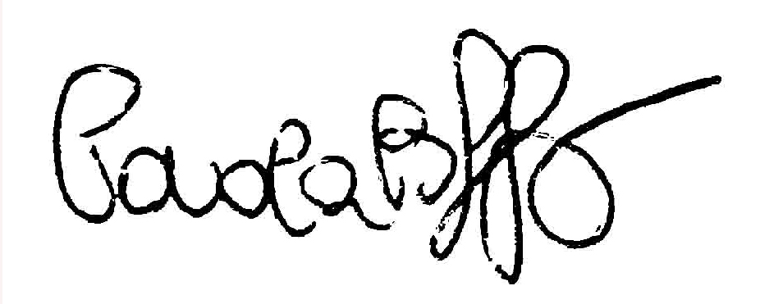

Paola Balbi, Artistic Director

